IBM – NALAIYA THIRAN

PROJECT REPORT

|  |  |
| --- | --- |
| PROJECT NAME | SIGNS WITH SMART CONNECTIVITY FOR BETTER ROADS |
| TEAM ID | PNT2022TMID28982 |
| TEAM MEMBERS | VIVEK V R(TEAM LEADER)  VIGNESH R  RITHU BHARATHAN S  SANJAI KUMAR P V M |
| DEPARTMENT | ELECTRONICS AND COMMUNICATION ENGINEERING |

1. **INTRODUCTION**
   1. **PROJECT OVERVIEW:**

Connected vehicle technology aim to solve some of the biggest challenges in the transportation in the areas of safety, mobility and environment. The safety application for Intelligent Transport System (ITS) is one of the main objectives in this project. Safety application is research and industrial initiative which aim to contribute to the global advancement of automobile industry. In this project we focus on V2V communication, once cars are connected which is able to share data with other cars on the road and which help to reduce Highway accidents. Ultimately, vehicles are connect via multiple complementary technologies of vehicle to-vehicle (V2V) and vehicle-to-infrastructure (V2I) connectivity based on Wi-Fi, GPS, Dedicated Short Range Communication (DSRC). VANETS are also considered as one of the most important Simulator for safety of intelligent transportation systems. The use of the DSRC technologies support low latency vehicle-to-vehicle (V2V) communication. In present Systems the road signs and the speed limits are static. But the road signs can be changed in some cases. We can consider some cases when there are some road diversions due to heavy traffic or due to accidents then we can change the road signs accordingly if they are digitalized. This project proposes a system which has digital sign boards on which the signs can be changed dynamically. If there is rainfall then the roads will be slippery and the speed limit would be decreased. There is a web app through which you can enter the data of the road diversions, accident prone areas and the information sign boards can be entered through web app. This data is retrieved and displayed on the sign boards accordingly. Clearly, intelligent roadway placards can be a vital part of our driving experience. They enable a better way for drivers to access the information they need in real time on the roads. These signs can increase awareness of upcoming issues, which people might otherwise discover too late. They may also augment the functionality of driverless vehicles.

* 1. **PURPOSE**

The value of implementing this technology should not be underestimated. Smart roadway indicators have the potential to increase cost-efficiency, which eases the burden on governments and taxpayers. They facilitate a smoother driving process for both human drivers and autonomous vehicles. The placards can be more user-friendly than the analog route signs we currently employ. Above all, they may ultimately lead to a safer network of roads for everyone. Smart roadway signage is not simply an objective for the future. Two UK Companies have collaborated to produce these signs for use on England’s roads. The signs are technologically advanced, with graphics and text that drivers can see clearly. The messages are easy to comprehend quickly, keeping drivers informed of route conditions as they change. In addition to enhancing the roadway experience for users, this new signage costs less to maintain than traditional indicators. The new signs require fewer materials and less cabling, resulting in less time, upkeep, and expense. Increasing volumes of traffic are using municipal road infrastructure, with severe consequences for traffic efficiency and the safety of road users. Vulnerable roads users (VRUs), such as pedestrians or cyclists, are involved in 46 % of lethal accidents. Exchanging information between road users increases their perception and is thus a critical building block to improve this situation. We have presented a system, to alert the driver about the speed limits in specific areas and reduce the speed of the vehicles in sensitive public zones without any interference of the drivers where controls are taken automatically by the use of a wireless local area networks.

1. **LITERATURE**
   1. **EXISTING PROBLEM**

The Existing road system and connectivity, emphasis on the traffic and route reckoning features which cordially provisions the user acceptability to have better connectivity management. But, this often results in nonparallel road conditions and high noise ratios through the calibrations. It reiterates various subjections in its compilation and leading to segmentation error throughout. It penetrates the various unit cases in order to subsequently manifest the output. This alternatively symbolizes the ineffectively programmed web user interface. The IOT based model of our project complies of the verdict to specify the soft zone in the path. It manually ask the user to turn off the horn, which in variably decreases the decibel level of the power output. Illustratively, it confides the work schematics of the precedent evaluation under the system and allows the user to access the terminals of the app nodes variably. IBM Cloud indefinitely helps in reviving the data sets required in web application. MIT app inventor segments the creation of the user interface.

* 1. **REFERENCES**

1. Ashish Dhar: **Traffic and road condition monitoring system**

Indian Institute of Technology, Mumbai. - 2008.

• Reports severity, intensity and dimension of a damaged road segment.

• Proposed a different solution using AMR Magnetic Sensor.

2. Pooja Pawar, Suvarna Langade, Mohini Bandgar: **IOT Based digital Notice Board using Arduino ATMega 328.**

International Research Journal of Engineering and Technology(IRJET).- 2019.

• Circulates notice regularly & reduce physical efforts.

• Send message at any distant location within a second.

3. Sandeep Chaware, Trushitha Chaware: **Proposed Algorithm for Smart Traffic Control using Ultrasonic Sensor.**

International Journal of Engineering and Advanced Technology (IJEAT).- 2019.

• The outcome of the project is to learn insights of the traffic controlling and management at the signal with the dynamically changing in timing of timer as per need.

4. Kamna Singh, Deepa Bura: **IOT distinct algorithms for the Sensor Connectivity with Comparative Study between node MCU and Arduino MCU.**

NVEO Journal – 2021

• Presents different algorithms for the connection between different types of sensors.

• Brief description of node MCU & Arduino MCU.

• Step by step solution to provide connectivity with IOT technology.

5. Jack Greenhaigh: **Recognizing Text Based Traffic Signs.**

IEEE – 2015

• Detect all possible Road sign candidates.

• Reduce total regions based on contextual constraints.

• A Novel System for the automatic detection and recognition of text in traffic sign based on MSER & MSV.

6. Bhumika.R, Harshita. S.A, Meena. D, Asha. N: **Accident Prevention and Road Safety in Hilly Region using IOT Module**

International Research Journal of Engineering and Technology (IRJET) – 2021

• Stay away from mishap & forestall clog in sloping region & hairclip twist.

• As a significant part of street mathematical plan bended street portion

7. Sowparnika: **IOT Road Safety**

• This project paves a system to alert the driver about the speed limit in specific areas and to reduce the speed of vehicles in sensitive public zones without any interference of drivers where controls are taken automatically by use of wireless local area network.

8. S.S. Sugania, D. S. Vishalis Hwaran, J. Vignesh Kumar: **Automated System for Road Safety**

Enhancement using big data reports.

• The speed is controlled accordingly to situations to give suggestions.

• The suggested system can control the vehicle but at same time can collect data and manipulate it using the big data technologies.

9. **IOT Based Smart Road Safety & Vehicle Accident prevent System for Mountain roads.**

• This system is divided into 2 half (Accident Detection & Prevention) and alerting the members of family by causation message and placement of accidental place.

10. Shweta Vyas, Pooja Awhale, Shreya Kukdeja, Prashant Jawalkar: **A Modern Approach to identify Traffic Sign Symbols in Color Images.**

• In this technique proposed more reliable and robust method of Traffic Sign Detection Recognition (TSDR).

* 1. **PROBLEM STATEMENT DEFINITION**

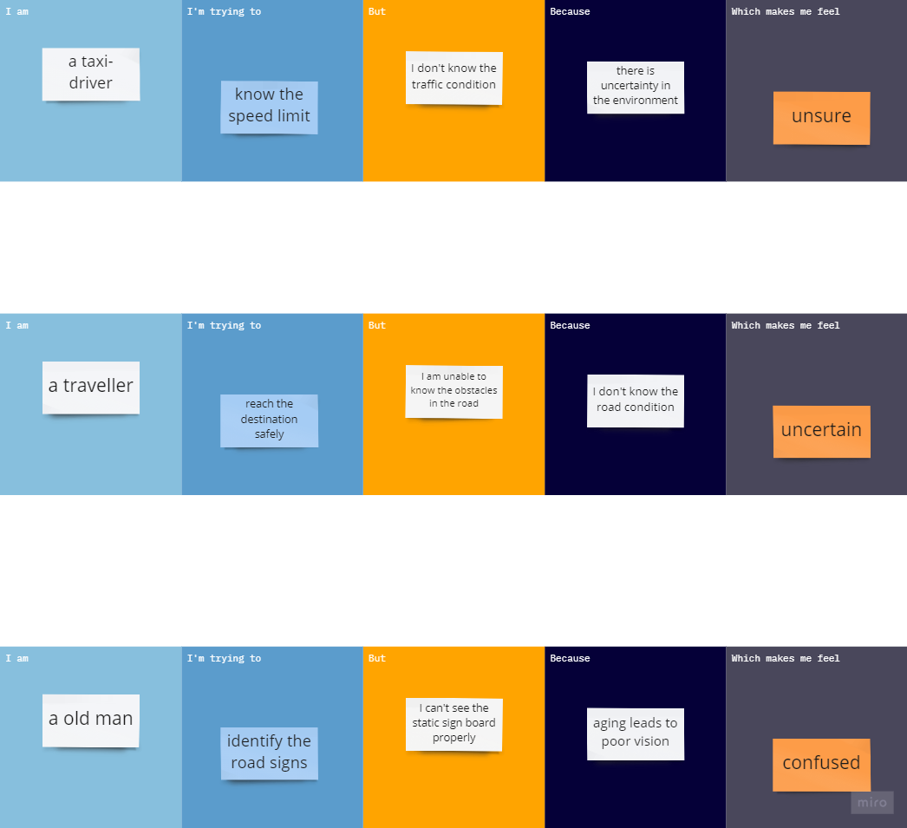

1. **IDEATION AND PROPOSED SOLUTION**
   1. **EMPATHY MAP**

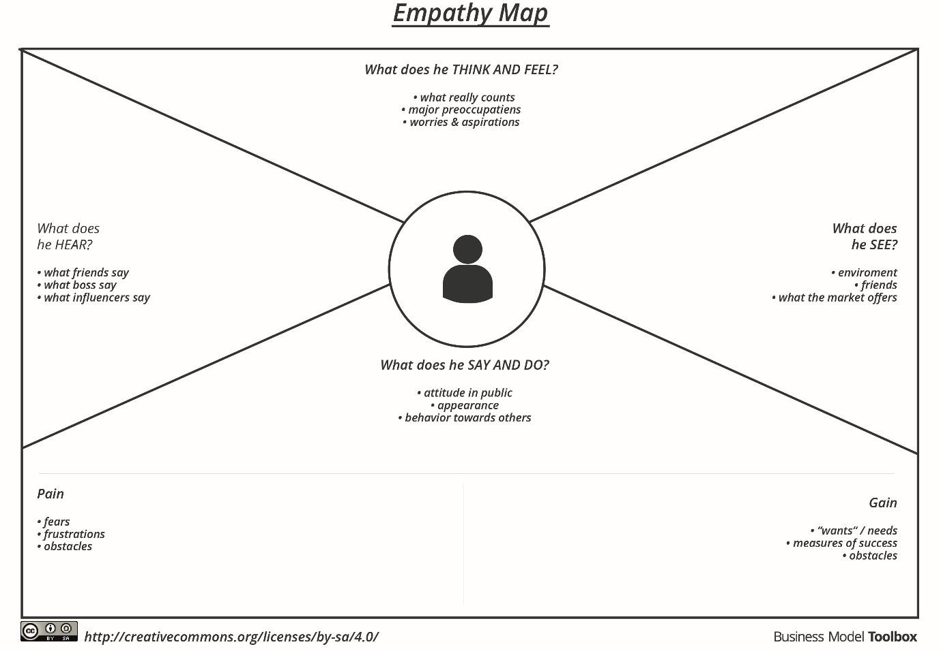

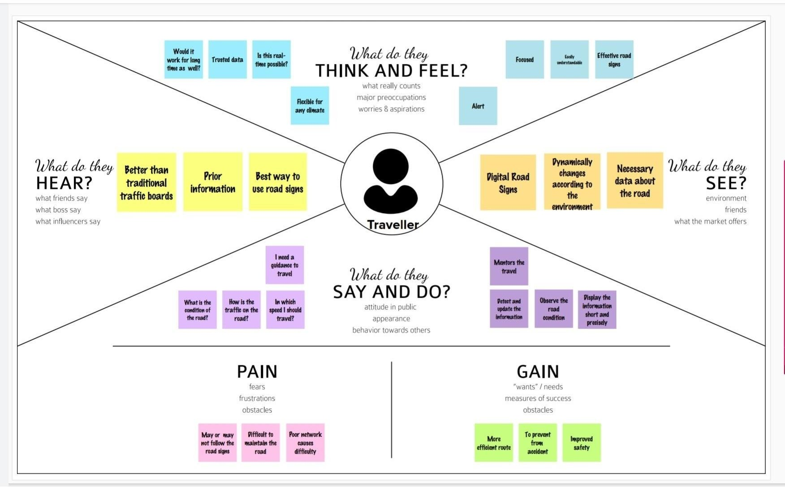

* 1. **IDEATION & BRAINSTORMING**

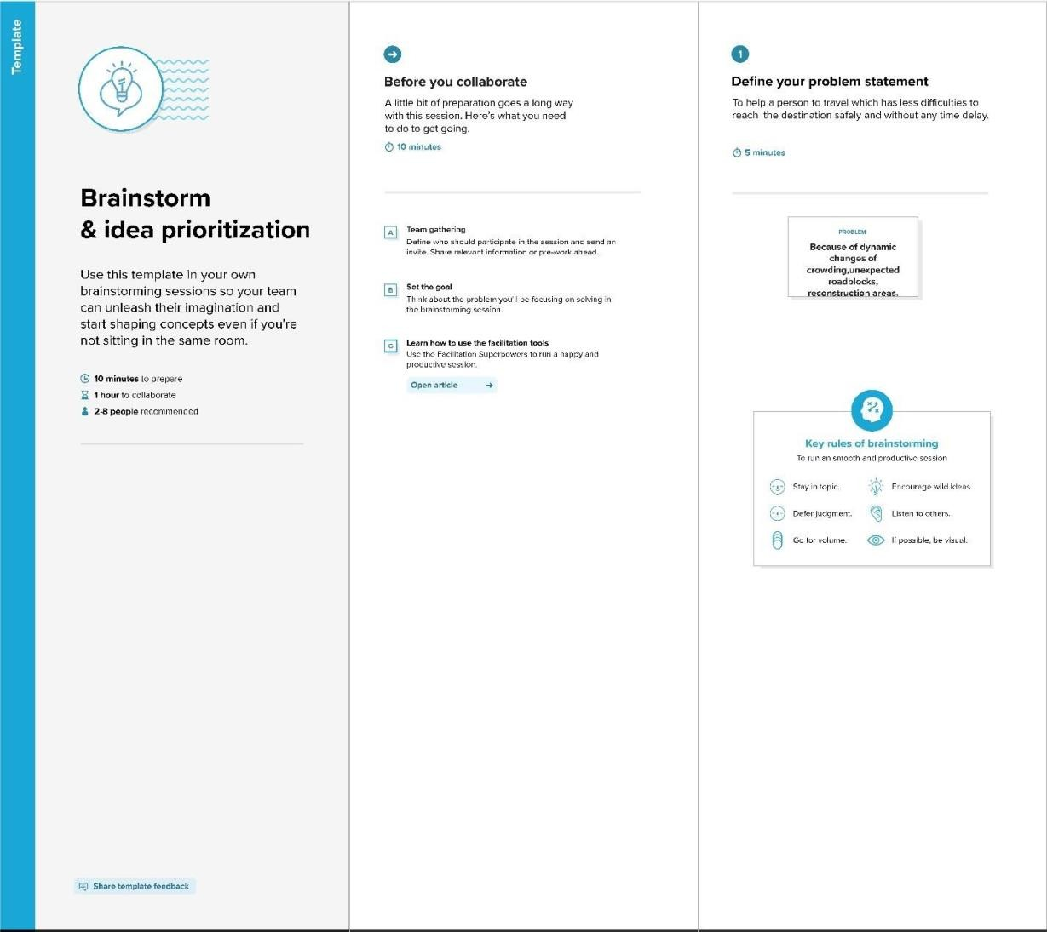

BRAINSTORMING, LISTING AND GROUPING

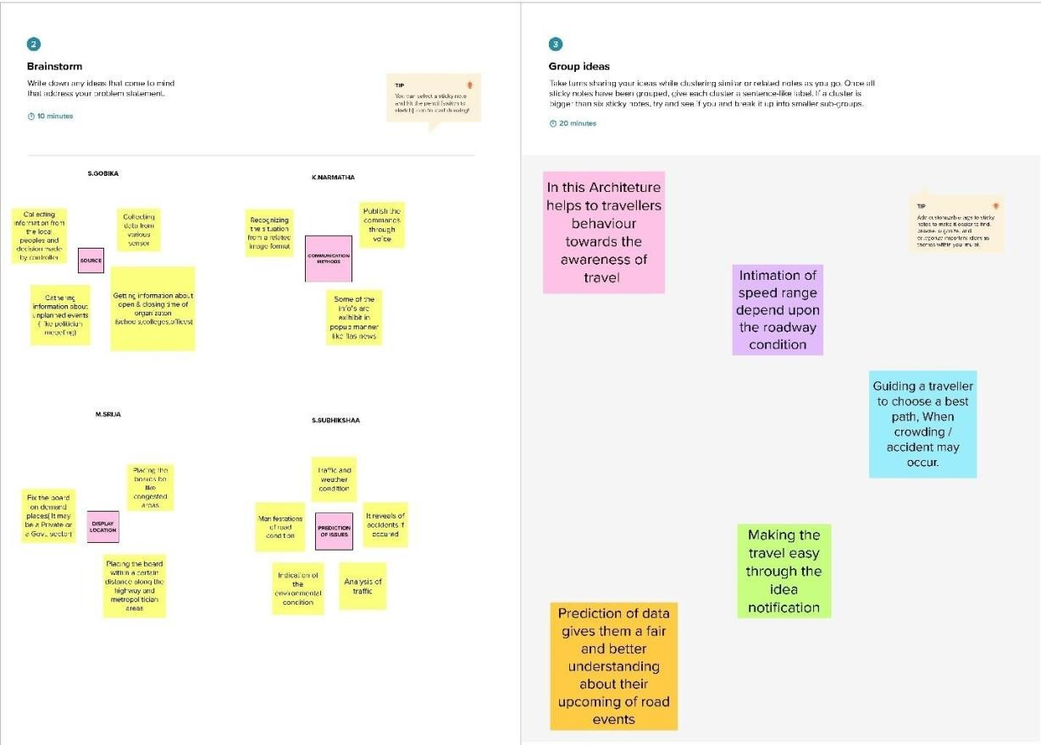

* 1. **PROPOSED SOLUTION**

|  |  |  |
| --- | --- | --- |
| **S.NO** | **PARAMETERS** | **DESCRIPTION** |
| 1 | PROBLEM STATEMENT (PROBLEM TO BE SOLVED) | * It helps the each user to understand the traffic system across the limits in the area. * It gradually fragments different parameters to relinquish the user interface to make it understand better. |
| 2 | IDEA/SOLUTION | * The given structured model of our project deeply enhances the web interface required for the user to access the depth of the segment in the system. * It Associates the details in confinement with application fragmented. |
| 3 | NOVELITY | * Switches are injected to project the soft zone surrounding in the segment. * It complies the visibility spectrum which enables better user interface in regards. |
| 4 | CUSTOMER SATISFACTION | * Awareness towards road infrastructure * Data is useful in understanding the road user behavior & flow of traffic |



1. **REQUIREMENT ANALYSIS**
   1. **Functional Requirements:**

Following are the functional requirements of the proposed solution.

|  |  |  |
| --- | --- | --- |
| **FR No.** | **Functional Requirement (Epic)** | **Sub Requirement (Story / Sub-Task)** |
| FR-1 | User visibility | * Informations can be written in short form in the sign boards so that it can be very easily captured by drivers. * Place sign boards on popular places. * Symbols can be used so that drivers can save some amount of time in reading. * Static signs can be replaced by smart signs to reduce accidents. |
| FR-2 | User convenience | * Display should be larger which can be visible from far distance. |
| FR-3 | User need | * Awareness programmes should be conducted to bring awareness among the users about road safety. * Road safety education is essential for users. |

# Non-functional Requirements:

# Following are the non-functional requirements of the proposed solution.

|  |  |  |
| --- | --- | --- |
| **FR No.** | **Non-Functional Requirement** | **Description** |
| NFR-1 | **Usability** | * When crowd on accident occur it guides the travellers to choose best path. * Intimates the speed range depending upon roadway condition. * Ensure the vehicles are redirected to right path without causing much trouble for other drivers. * Easy to follow instructions based on given data on the digital board. |
| NFR-2 | **Security** | * Prediction of data gives them a fair and better road understanding about their upcoming of toad events. |
| NFR-3 | **Reliability** | * Helps to travellers behaviour towards awareness of travel. |

1. **PROJECT DESIGN**
   1. **DATA FLOW DIAGRAM AND USER PLANNING**

<https://github.com/IBM-EPBL/IBM-Project-11553-1659334316/blob/main/Project%20Design%20and%20Planning/Project%20Design%20Phase%20-%2002/Data%20Flow%20Diagram.pdf>

**5.2 SOLUTION ARCHITECTURE**

<https://github.com/IBM-EPBL/IBM-Project-11553-1659334316/blob/main/Project%20Design%20and%20Planning/Project%20Design%20Phase%20-%2001/Solution%20Architecture.pdf>

1. **PROJECT PLANNING**
   1. **SPRINT PLANNING AND SCHEDUELING**

<https://github.com/IBM-EPBL/IBM-Project-11553-1659334316/tree/main/Project%20Design%20and%20Planning/Project%20Planning>

* 1. **SPRINT DELIVERY SCHEDUELE**

<https://github.com/IBM-EPBL/IBM-Project-11553-1659334316/tree/main/Project%20Design%20and%20Planning/Project%20Planning>

1. **SCHEMATIC CIRCUIT AND CODING SOLUTION**
   1. **CIRCUIT**

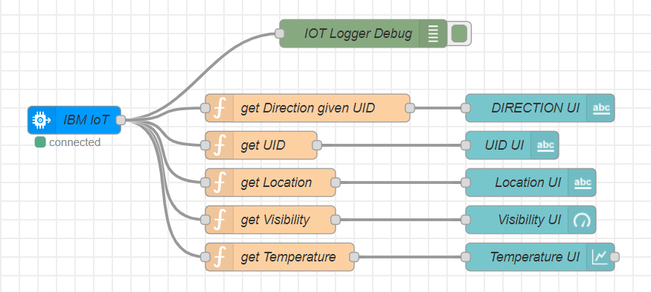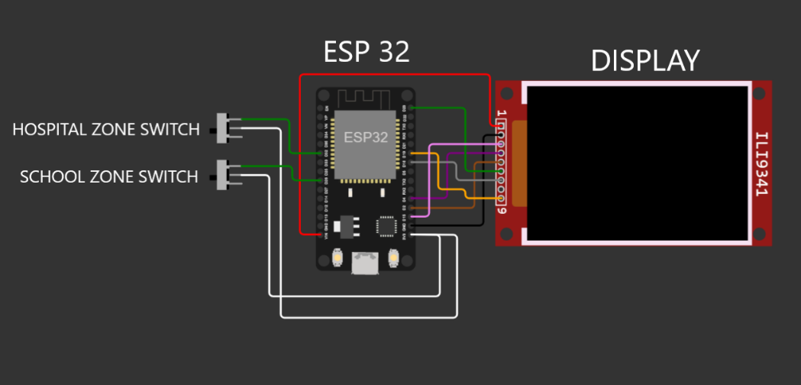

* "IBM IOT" node connects the backend to Node RED UI. The function nodes such as "get Direction given UID", "get UID", "get Location", "get Visibility" & "get Temperature" extract the respective data out and provides them to the UI nodes "Direction UI", "UID UI", "Location UI", "Visibility UI" & "Temperature UI".
* For the detailed explanation refer the url: <https://github.com/IBM-EPBL/IBM-Project-11553-1659334316/blob/main/Project%20Development%20Phase/Sprint%203/Sprint%2003.pdf>

8. **TESTING**

**8.1 TEST CASES**

● TEST CASE 1

Clear weather - Usual Speed Limit.

● TEST CASE 2

Foggy Weather - Reduced Speed Limit.

● TEST CASE 3

Rainy Weather - Further Reduced Speed Limit.

● TEST CASE 4

School/Hosipital Zone - Do not Honk sign is displayed.

**8.2 USER ACCEPTANCE TESTING**

Dynamic speed & divertion variations based on the weather and traﬃc helps user to avoid traﬃc and have a safe journey home. The users would welcome this idea to be implemented everywhere.

**9. RESULTS**

**9.1 PERFORMANCE METRICS**

Based on the IBM pack we chose, the performance of the website varies. Built upon NodeJS, a light and high performance engine, NodeRED is capable of handling upto 10,000 requests per second. Moreover, since the system is horizontally scalable, a even higher demand of customers can be served.

**10. ADVANTAGES & DISADVANTAGES**

**● ADVANTAGES**

○ Lower battery consumption since processing is done mostly by Node RED servers in the cloud.

○ Cheaper and low requirement micro controllers can be used since processing requirements are reduced.

○ Longer lasting systems.

○ Dynamic Sign updation.

○ School/Hospital Zone alerts

● **DISADVANTAGES**

○ The size of the display determines the requirement of the micro controller

○ Dependent on OpenWeatherAPI and hence the speed reduction is same for a large area in the scale of cities.

**11. CONCLUSION**

Our project is capable of serving as a replacement for static signs for a comparatively lower cost and can be implemented in the very near future. This will help reduce a lot of accidents and maintain a more peaceful traﬃc atmosphere in the country.

**12. FUTURE SCOPE**

Introduction of intelligent road sign groups in real life scenarios could have great impact on increasing the driving safety by providing the end-user (car driver) with the most accurate information regarding the current road and traﬃc conditions. Even displaying the information of a suggested driving speed and road surface condition (temperature, icy, wet or dry surface) could result in smoother traﬃc ﬂows and, what is more important, in increasing a driver’s awareness of the road situation.

**13. APPENDIX**

* **GITHUB AND PROJECT DEMO LINK**

<https://github.com/IBM-EPBL/IBM-Project-11553-1659334316>

* DEMO VIDEO DOWNLOAD LINK

<https://github.com/IBM-EPBL/IBM-Project-11553-1659334316/blob/main/Final%20Deliverables/DEMO%20SMART%20CONNECTIVITY%20FOR%20BETTER%20ROADS.mp4>

* **SOURCE CODE - ESP 32**

#include <WiFi.h>

#include <HTTPClient.h>

#include <Adafruit_GFX.h>

#include <Adafruit_ILI9341.h>

#include <string.h>

const char* ssid = "Wokwi-GUEST";

const char* password = "";

#define TFT_DC 2

#define TFT_CS 15

Adafruit_ILI9341 tft = Adafruit_ILI9341(TFT_CS, TFT_DC);

String myLocation = "Chennai,IN";

String usualSpeedLimit = "70"; // kmph

int schoolZone = 32;

int hospitalZone = 26;

int uid = 2504; // ID Unique to this Micro Contoller

String getString(char x)

{

    String s(1, x);

    return s;

}

String stringSplitter1(String fullString,char delimiter='$')

{

    String returnString = "";

    for(int i = 0; i<fullString.length();i++) {

        char c = fullString[i];

        if(delimiter==c)

            break;

        returnString+=String(c);

    }

    return(returnString);

}

String stringSplitter2(String fullString,char delimiter='$')

{

    String returnString = "";

    bool flag = false;

    for(int i = 0; i<fullString.length();i++) {

        char c = fullString[i];

        if(flag)

            returnString+=String(c);

        if(delimiter==c)

            flag = true;

    }

    return(returnString);

}

void rightArrow()

{

  int refX = 50;

  int refY = tft.getCursorY() + 40;

  tft.fillRect(refX,refY,100,20,ILI9341_RED);

  tft.fillTriangle(refX+100,refY-30,refX+100,refY+50,refX+40+100,refY+10,ILI9341_RED);

}

void leftArrow()

{

  int refX = 50;

  int refY = tft.getCursorY() + 40;

  tft.fillRect(refX+40,refY,100,20,ILI9341_RED);

  tft.fillTriangle(refX+40,refY-30,refX+40,refY+50,refX,refY+10,ILI9341_RED);

}

void upArrow()

{

  int refX = 125;

  int refY = tft.getCursorY() + 30;

  tft.fillTriangle(refX-40,refY+40,refX+40,refY+40,refX,refY,ILI9341_RED);

  tft.fillRect(refX-15,refY+40,30,20,ILI9341_RED);

}

String APICall() {

  HTTPClient http;

  String url = "http://169.51.194.120:31149/getSpeed?";

  url += "location="+myLocation+"&";

  url += "schoolZone="+(String)digitalRead(schoolZone)+(String)"&";

  url += "hospitalZone="+(String)digitalRead(hospitalZone)+(String)"&";

  url += "usualSpeedLimit="+(String)usualSpeedLimit+(String)"&";

  url += "uid="+(String)uid;

  http.begin(url.c_str());

  int httpResponseCode = http.GET();

  if (httpResponseCode>0) {

    String payload = http.getString();

    http.end();

    return(payload);

  }

  else {

**Serial**.print("Error code: ");

**Serial**.println(httpResponseCode);

  }

  http.end();

}

void myPrint(String contents) {

  tft.fillScreen(ILI9341_BLACK);

  tft.setCursor(0, 20);

  tft.setTextSize(4);

  tft.setTextColor(ILI9341_RED);

  //tft.println(contents);

  tft.println(stringSplitter1(contents));

  String c2 = stringSplitter2(contents);

  if(c2=="s") // represents Straight

  {

    upArrow();

  }

  if(c2=="l") // represents left

  {

    leftArrow();

  }

  if(c2=="r") // represents right

  {

    rightArrow();

  }

}

void setup() {

  WiFi.begin(ssid, password, 6);

  tft.begin();

  tft.setRotation(1);

  tft.setTextColor(ILI9341_WHITE);

  tft.setTextSize(2);

  tft.print("Connecting to WiFi");

  while (WiFi.status() != WL_CONNECTED) {

    delay(100);

    tft.print(".");

  }

  tft.print("\nOK! IP=");

  tft.println(WiFi.localIP());

}

void loop() {

  myPrint(APICall());

  delay(100);

}

LINK TO NODE RED DASHBOARD

<http://169.51.194.120:31149/ui/#!/0?socketid=AE2oxZhewQ6TYiYrAAD7>

<http://169.51.194.120:31149/set>

LINK TO WORKWI SIMULATION

<https://wokwi.com/projects/348310225114104404>